A Project Report Submitted to

**Department of Computer Science**



S.I.E.S College of Arts, Science and Commerce (Autonomous) Sion (W)

Mumbai– 400 022

### GYM MANAGEMENT

 Fulfillment for The Degree Of Bachelor of Science (Computer Science) 2021-2022

https://lh3.googleusercontent.com/qd9UZWk-DJJj8sysBp8tW3BUJvLNeS2F8bgnLHLgFgNHmYh9DMmLIjwoYvJgZAvQPUvD3E3dUJ_TinSTt5bEkxry9jdfJSWIAeXO-oYudKV0N4OkAH5ALm_8tbndT6m_68q_x3p1https://lh4.googleusercontent.com/pvjqflqTaY4cFHc60LABM6BE7I8taHlzbDI1I5Uz0NlmX0sXzYrOiaR5QMQB6aMdjwt6lYiYlEB1jHaA0vSJ8a-6rgiHyZCG74IJJWKjtKkyPU2OtPAiFv9S2oLso7pv0qrwlS4p

**Head of Department                                                                                 Project Guide**

        Prof. Manoj Singh                                                                               Prof. Manoj Singh

**Submitted by**

BHUSHAN KANADE - TCS2122036

ARUN KANJOOR - TCS2122037

KARTIK BHANDARY - TCS2122038

# **Acknowledgement:-**

First and foremost we would like to express our sincere gratitude to our Head of Department and also our project advisor **Mr Manoj Singh** for the continuous support and guidance during the making of our project, for their patience, motivation, enthusiasm and immense knowledge. His guidance helped us in all the time of research and building this project.

**INDEX**

|  |  |
| --- | --- |
| **Chapter No** | **Topic** |
| **1** | **Introduction** |
| 1.1 | Overview |
| 1.2 | Drawbacks found in the system |
| 1.3 | Solutions Provided By Our System |
| 1.4 | Gantt Chart |
| **2** | **Stakeholders and Modules** |
| 2.1 | Stakeholders |
| 2.2 | Modules |
| 2.3 | Module Description |
| 2.4 | Tech Stack To Be Used |
| **3** | **System Analysis** |
| 3.1 | Event Table |
| A | Admin |
| B | Member |
| C | Trainer |
| D | Receptionist |
| 3.2 | Function Point Analysis |
| 3.3 | Fi Questions |
| 3.4 | Time Estimation |
| 3.5 | Cost Estimation |
| 3.6 | Server and Hosting |
| 3.7 | Hardware Cost |
| **4** | **UML Diagrams** |
| 4.1 | System Diagrams |
| 4.1.1 | Use Case Diagrams |
| A | Admin Diagram |
| B | Employee Diagram |
| C | Receptionist Diagram |
| D | Member Diagram |
| 4.1.2 | Sequence Diagram |
| A | Admin Sequence Diagram |
| B | Member Sequence Diagram |
| C | Employee Sequence Diagram |
| 4.1.3 | Activity Diagram |
| 4.1.4 | Decision Tree Diagram |
| A | Admin Decision Tree |
| B | Employee Decision Tree |
| C | Member Decision Tree |
| 4.1.5 | ER Diagram |
| **5** | **Testing** |
| 6.1 | Chi Square Testing |
| **6** | **Code** |
| 7.1 | Screenshot |
| **7** | **Output of Project** |
| 8.1 | Home Screen |
| 8.2 | Login Page |
| 8.3 | Admin Dashboard |
| 8.4 | Member Registration Form |
| 8.5 | Employee Registration Form |
| 8.6 | Product Registration Form |
|  | **References** |

**Chapter 1**

**Introduction**

### **Overview**:

Online service is the best competitive edge for any organization which makes it differ from other organizations nowadays.

This gym management project is designed to facilitate a gymming and fitness center to automate its operations of keeping records and store them in the form of a large and user-friendly database further facilitating easy access to the personnel and help the members to view their diet, workouts, and plans.

This is a best platform for members and gym staff to interact freely and comfortably with each other

**1.2)Drawbacks Found in the Existing System:**

* Every work/task/record in the existing system is done on paper manually which takes much more time
* The existing system is more time consuming.
* The present system is not online, so there are many drawbacks for the administration and members. Members cannot see online:
  + Payment of fees paid by them
  + Record of attendance
  + Trainer profile
  + Batches timing
* Everything is on paper hence it requires more security, more space to store and records have to be kept in a physically safe location.

**1.3)Solutions Provided By Our System:**

* Total computerization of the activities of the gym
* Our system is fast and easy to use.
* Our proposed system allows users to save their respective info and record it in the database.
* Member Dashboard– members can manage their own Profile
* The software will store information about employees, products, etc.
* Billing & invoicing for better and faster payment.

### **1.4)Gantt Chart:-**

### 

**Chapter 2**

**Stakeholders and Modules**

**2.1)Stakeholders:**

1. Members
2. Receptionist
3. Trainers
4. Admin

**2.2)Modules:**

* **Admin module**
* **Dashboards**
* **Attendance module**
* **Billing module**
* **Login module**
* **Registration module**

**2.3)Module Description:-**

* **Admin Module:-**

This module will have access to all the stakeholder's

data and can make changes to them

* **Dashboard Module**

This module will display all stakeholder’s details and let users keep track of all their progress and data.

* **Billing Module**

In this module the payment operations like buying and renewing of different packages will be carried out.

* **Login Module**

In this module login activity is carried out. For logging in users will need an Email id and Password.

* **Registration Module**

In this module the activity of adding new members will be carried out.

* **Attendance Module**

In this module the member’s and employees' attendance will be marked and can be tracked.

**2.4)Tech Stack used:**

* React JS -frontend
* Fast API(Python)- backend
* PostgreSQL- database

**Chapter 3**

**System Analysis**

**3.1)Event Table :**

**a)Admin :**

|  |  |  |  |  |  |  |
| --- | --- | --- | --- | --- | --- | --- |
| Sr. no | Event | Trigger | Source | Activity | Response | Destination |
| 1 | Login | Enter Username and password | Admin | System will Verify credentials | System will redirect to admin dashboard | Admin |
| 2 | View Member info | System will list every member | Admin | Admin wil click on member details and fetch particular member info | System will display the member details | Admin |
| 3 | Add Member Info | System will show option to add member info | Admin | Admin will click on Add member info | Member info will be added | Admin |
| 4 | Delete Member info | System will show option to delete member info | Admin | Admin will click on Delete member info | Member info will be Deleted | Admin |
| 5 | View Employee info | System wll list every employee | Admin | Admin will click on Employee details and Fetch particular Employee info | System will display the employee details | Admin |
| 6 | Add Employee Info | System will show option to Add employee info | Admin | Admin will click on Add employee | Employee info will be added | Admin |
| 7 | Delete Employee info | System will show option to Delete employee info | Admin | Admin will click on Delete employee info | Employee info will be Deleted | Admin |
| 8 | View supplement provider info | System will list supplement provider | Admin | Admin will click on supplement provider details and will fetch provider info | Provider details will be displayed | Admin |
| 9 | Delete provider info | System will show option to delete provider info | Admin | Admin will click on delete provider info | Provider info will be deleted | Admin |
| 10 | Add provider info | System will show option to Add provider info | Admin | Admin will click on add provider info | Provider info will be Added | Admin |
| 11 | View Supplement Product | System will list all products | Admin | Admin will click on product details and Fetch product info | Product details will be displayed | Admin |
| 12 | Add product info | System will show option to add product info | Admin | Admin will click on Add product info | Product details will be Added | Admin |
| 13 | Delete product | System will show option to delete product | Admin | Admin will click on Delete product | Product will be Deleted | Admin |
| 14 | View Equipment | System will list all Equipments | Admin | Admin will click on Equipment info and Fetch equipment details | Equipment details will be displayed | Admin |
| 15 | Add equipment info | System will show option to add equipment info | Admin | Add equipment | Added equipment | Admin |
| 16 | Delete equipment | Click on delete equipment | Admin | Delete equipment | Deleted equipment | Admin |
| 17 | View maintenance date | click on upcoming maintenance | Admin | fetch maintenance details | display maintenance date | Admin |
| 18 | set maintenance date | click on new maintenance | Admin | Add maintenance date | Added maintenance date | Admin |
| 19 | Update Maintenance date | Click on update maintenance date | Admin | Update the maintenance date | Updated the maintenance date | Admin |
| 20 | Delete Maintenance date | Delete Maintenance date | Admin | Delete the maintenance date | Deleted the maintenance date | Admin |
| 21 | Post a community message | Click on send broadcast message | Admin | Write the message | Message sent | Everyone |
| 22 | Logout | click on log out | Admin | log out | logged out | Admin |
| 23 | Approve leave | Click on approve | Admin | Approve leave | Leave approved | Admin, Employee |
| 24 | Reject Leave | Click on reject | Admin | Reject leave | Leave rejected | Admin, Employee |

**B)Member:**

|  |  |  |  |  |  |  |
| --- | --- | --- | --- | --- | --- | --- |
| SR NO | EVENT | TRIGGER | SOURCE | ACTIVITY | RESPONSE | DESTINATION |
| 1 | VIEW NAME | DASHBOARD WILL SHOW MEMBERS NAME | GYM MEMBER | MEMBER CAN SEE HIS NAME | SYSTEM WILL SHOW MEMBER’S NAME | MEMBER |
| 2 | VIEW PROFILE PICTURE | DASHBOARD WILL SHOW MEMBER’S PROFILE PICTURE | GYM MEMBER | MEMBERS CAN SEE THEIR PROFILE PICTURE | SYSTEM WILL SHOW MEMBER’S PROFILE PIC | MEMBER |
| 5 | ADD BODY MEASUREMENTS | DASHBOARD WILL PROVIDE OPTIONS FOR ADDING BODY MEASUREMENTS | GYM MEMBER | MEMBER’S WILL SEE ADD THEIR BODY MEASUREMENTS | BODY MEASUREMENTS WILL BE ADDED | GYM MEMBER |
| 6 | UPDATE BODY MEASUREMENTS | DASHBOARD WILL PROVIDE OPTIONS TO UPDATE BODY MEASUREMENTS | GYM MEMBER | MEMBER’S WILL CHANGE THEIR BODY MEASUREMENTS | BODY MEASUREMENTS WILL BE CHANGED | GYM MEMBER |
| 7 | VIEW PACKAGE INFORMATION | DASHBOARD WILL SHOW MEMBER’S PACKAGE INFO | GYM MEMBER | MEMBER’S WILL ACCESS THE INFORMATION ABOUT RESPECTIVE PACKAGE | SYSTEM WILL SHOW INFO ABOUT THE PACKAGE | MEMBER |
| 8 | RENEW/  CHANGE PACKAGE | SYSTEM WILL SHOW DIFFERENT PACKAGE INFORMATION | GYM MEMBER | MEMBER’S WILL CHOOSE THE PACKAGE THEY ANT AMONG THE OPTIONS | PACKAGE WILL BE CHANGED/ RENEWED | GYM MEMBER, ADMIN |
| 9 | VIEW TRAINER INFORMATION | DASHBOARD WILL SHOW EVERY TRAINER’S INFO | GYM MEMBER | MEMBER’S CAN ACCESS EVERY TRAINER’S INFO | SYSTEM WILL SHOW INDIVIDUAL TRAINER INFO TO THE MEMBERS | GYM MEMBER |
| 11 | VIEW WORKOUT SCHEDULE | DASHBOARD WILL SHOW THE DAILY WORKOUT SCHEDULE | GYM MEMBER | MEMBER’S CAN CHECK THE DAILY WORKOUT SCHEDULE OF GYM | SYSTEM WILL SHOW THE DAILY WORKOUT SCHEDULE TO THE MEMBERS | GYM MEMBER |
| 12 | VIEW DIET PLAN | DASHBOARD WILL SHOW THE RESPECTIVE DIET PLAN OF A MEMBER | GYM MEMBER | MEMBER’S WILL CHECK THEIR RESPECTIVE DIET PLAN TO FOLLOW | SYSTEM WILL SHOW THE MEMBER’S THEIR RESPECTIVE DIET PLAN | GYM MEMBER |
| 13 | CHANGE DIET PLAN | DASHBOARD WILL PROVIDE OPTIONS FOR THE CHANGES IN DIET PLAN | GYM MEMBER | MEMBERS WILL CHANNGE THEIR DIET PLAN | DIET PLAN WILL BE CHANGED | GYM MEMBER |
| 15 | LOG IN | CLICK ON LOGIN BUTTON | MEMBER | VERIFY CREDENTIALS | LOGGED IN | MEMBER |
| 16 | LOG OUT | CLICK ON LOG OUT | MEMBER | LOG OUT | LOGGED OUT | MEMBER |
| 17 | VIEW SUPPLEMENTS | CLICK ON SUPPLEMENTS | MEMBER | FETCH SUPPLEMENT INFO | MEMBERS CAN CHECK OUT SUPPLEMENTS | MEMBER |
| 18 | BUY SUPPLEMENTS | CLICK ON BUY SUPPLEMENTS | MEMBER | BUY SUPPLEMENTS | MEMBERS CAN BUY SUPPLEMENTS | MEMBER, ADMIN |

**C)Trainer:**

|  |  |  |  |  |  |  |
| --- | --- | --- | --- | --- | --- | --- |
| SR.NO | EVENT | TRIGGER | SOURCE | ACTIVITY | RESPONSE | DESTINATION |
| 1 | TRAINER NAME | DASHBOARD WILL SHOW THE TRAINER’S NAME | GYM TRAINER | TRAINER WILL SEE HIS NAME DISPLAYED | SYSTEM WILL DISPLAY TRAINER’S NAME | GYM TRAINER |
| 2 | ADD PROFILE PICTURE | DASHBOARD WILL SHOW OPTIONS TO CHANGE PROFILE PICTURE | GYM TRAINER | TRAINER WILL ADD HIS PROFILE PICTURE | PROFILE PICTURE WILL BE ADDED | GYM TRAINER |
| 3 | VIEW PROFILE PICTURE | DASHBOARD WILL SHOW TRAINER’S PROFILE PICTURE | GYM TRAINER | TRAINER WILL VIEW HIS PROFILE PICTURE | SYSTEM WILL DISPLAY TRAINER’S PROFILE PICTURE | GYM TRAINER |
| 4 | REMOVE PROFILE PICTURE | DASHBOARD WILL SHOW OPTION TO REMOVE PROFILE PICTURE | GYM TRAINER | TRAINER WILL REMOVE HIS PROFILE PICTURE | PROFILE PICTURE WILL BE REMOVED | GYM TRAINER |
| 5 | VIEW SCHEDULE | DASHBOARD WILL SHOW PARTICULAR TRAINER’S SCHEDULE | GYM TRAINER | TRAINER WILL CHECK HIS DAILY SCHEDULE | SYSTEM WILL DISPLAY TRAINER’S DAILY SCHEDULE | GYM TRAINER |
| 7 | VIEW MEMBER INFORMATION | SYSTEM WILL LIST EVERY MEMBER’S INFO | GYM TRAINER | TRAINER WILL ACCESS INDIVIDUAL MEMBER’S INFO | SYSTEM WILL DISPLAY MEMBER’S INFORMATION | GYM TRAINER |
| 8 | ADD ACHIEVEMENTS | DASHBOARD WILL SHOW OPTION TO ADD ACHIEVEMENTS | GYM TRAINER | TRAINER WILL ADD HIS ACHIEVEMENTS | ACHIEVEMENTS WILL BE ADDED | GYM TRAINER |
| 9 | UPDATE ACHIEVEMENTS | DASHBOARD WILL PROVIDE OPTIONS TO UPDATE | GYM TRAINER | TRAINER WILL UPDADE THEIR ACHIEVEMENTS | ACHIEVEMENTS WILL BE UPDATED | GYM TRAINER |
| 10 | VIEW MEMBER HEALTH INFORMATION | DASHBOARD WILL PROVIDE INDIVIDUAL MEMBER’S INFORMATION | GYM TRAINER | TRAINER WILL SEE EVERY MEMBER’S HEALTH INFORMATION | SYSTEM WILL DISPLAY HEALTH OF EVERY MEMBER | GYM TRAINER |
| 13 | APPLY LEAVE | CLICK ON APPLY LEAVE | GYM TRAINER | APPLY LEAVE | LEAVE APPLIED | GYM TRAINER, ADMIN |
| 15 | LOG IN | CLICK ON LOGIN BUTTON | GYM TRAINER | VERIFY CREDENTIALS | LOGGED IN | GYM TRAINER |
| 16 | LOG OUT | CLICK ON LOG OUT | TRAINER | LOG OUT | LOGGED OUT | TRAINER |
| 17 | VIEW SUPPLEMENTS | CLICK ON SUPPLEMENTS | TRAINER | FETCH SUPPLEMENT INFO | MEMBERS CAN CHECK OUT SUPPLEMENTS | TRAINER |
| 18 | BUY SUPPLEMENTS | CLICK ON BUY SUPPLEMENTS | MEMBER | BUY SUPPLEMENTS | MEMBERS CAN BUY SUPPLEMENTS | MEMBER, ADMIN |

**D)Receptionist:**

|  |  |  |  |  |  |
| --- | --- | --- | --- | --- | --- |
| Event | Trigger | Source | Activity | Response | Destination |
| Add Member | Click Member info | Receptionist | To add new members info from database | New member info added. | Receptionist |
| Delete Member Info | Click Delete Member info | Receptionist | To delete old member data from database | Member info deleted | Receptionist |
| Add Trainer | Click Add Trainer info | Receptionist | To add new trainers info from database | Trainer info added. | Receptionist |
| Change trainer schedule. | Click trainer info | Receptionist | To Edit a trainers schedule from database | Trainer schedule changed. | Receptionist |
| Send promotional messages | Click Member info | Receptionist | For Sending scheduled promotional messages to the new people. | Messages sent. | Members |
| Check Schedule. | Click profile info. | Receptionist | To check the daily/weekly/monthly schedule. | Schedule table. | Receptionist. |
| Apply leave. | Click apply leave button | Receptionist | To apply for leave. | leave applied | Receptionist. |

**3.2)Function Point Analysis**

FPA is a technique used to measure software requirements based on the different functions that the requirement can be split into. Each function is assigned with some points based on the FPA rules and then these points are summarized using the FPA formula

External inputs :37

External outputs :28

External Inquiries :15

External Interfaces Files :4

Internal Files :1

|  |  |  |  |  |
| --- | --- | --- | --- | --- |
|  | Weighting Factor | | |  |
|  | Simple | Average | Complex | Count |
| Input | 15*2 | 25*4 | 2*6 | 142 |
| Output | 32*3 | 10*5 | 2*7 | 160 |
| Enquires | 2*2 | 4*2 | 2*6 | 24 |
| Logical files | 0*5 | 0*10 | 4*15 | 60 |
| external Interface files | 0*4 | 0*7 | 1*10 | 10 |
| Total |  |  |  | 359 |

**3.3)Fi questions**

|  |
| --- |
| 1. Backup and Recovery:5 |
| 1. Data Communication: 5 |
| 1. Distributed data processing: 3 |
| 1. Performance: 5 |
| 1. Heavily used configuration: 4 |
| 1. Transaction rate: 5 |
| 1. Online data entry: 5 |
| 1. End-user efficiency: 5 |
| 1. Online update: 3 |
| 1. Installation Ease: 1 |
| 1. Reusability: 3 |
| 1. Operational ease: 2 |
| 1. Facilitate change: 4 |
| 1. Complex Processing: 5 |

Total = 55

FPC = UFC * (0.65 + (sum(GSC) * .01))

FPC=359*(0.65+ 0.51)

=359*1.2

=430.8

**3.4)Time estimation:**

430.8 divided by 54 function points= 7.97 man-months

**3.5)Cost estimation:**

* If the average programmer is paid 30,000 per month (including benefits), then the labor cost of the project will be

8.79 man-months* Rs.30000 = **Rs.239,100**

* **3.6)Server and Hosting:**
  + We recommend the following plans for Server and hosting :
  + Small Gym (Only 1 branch):
    - Shared Hosting (50Rs - 100Rs Per Month)
  + Big Gym (Multiple Branches):
    - Cloud Hosting (1000Rs - 3000Rs Per Month)
  + Domain:
  + Registration Cost (1,500Rs -3,000Rs+)
* **3.7)Hardware Cost :**
  + Admin System :
    - CPU: AMD Ryzen 3 3100 (4C 8T) (9,000 Rs+)
    - Motherboard: B450m DS3H (8,555 Rs+)
    - Memory: 8GB 3000MHz (6,000 Rs+)
    - Storage: Primary: 240GB M.2 NVME SSD (3,500 Rs+)
    - Secondary : 2TB WD Blue 5400 RPM HDD (5,000Rs+)
    - PSU: 550 Watt (3,372Rs+)
    - Cabinet: Any Mid Tower (2,000+)
    - Monitor: 1080p (60/75Hz Panel) (5,000Rs - 10,000Rs or greater)
    - Peripherals: Mouse, Keyboard (1,000Rs or greater)
    - **Total: Rs.45,427**
  + Other users :
    - Any device that can run a Web Browser can run our program for other users.

The total cost of the software could be **Rs.284527/-.**

Including some overhead (like software licences and other miscellaneous expenses), the total cost of software can be considered to be around **Rs.350,000.** (This is an Upper-bound estimate)

**Chapter 4**

**UML Diagrams**

**4.1)System Diagrams**

**4.1.1) Use Case Diagrams:**

A use case diagram is a graphical depiction of a user's possible interactions with a system.

A use case diagram shows various use cases and different types of users the system has and will often be accompanied by other types of diagram as well.

The use cases are represented by either circles or ellipses. The actors are often shown as stick figures.

Use case diagrams are valuable for visualizing the functional requirements of a system that will translate into design choices and development properties. They also model the behaviour of a system and help to capture the requirements of the system.

Use case diagrams describe the high-level functions and scope of a system. These diagrams also identify the interactions between the system and its factors

1. **Admin Diagram:-**

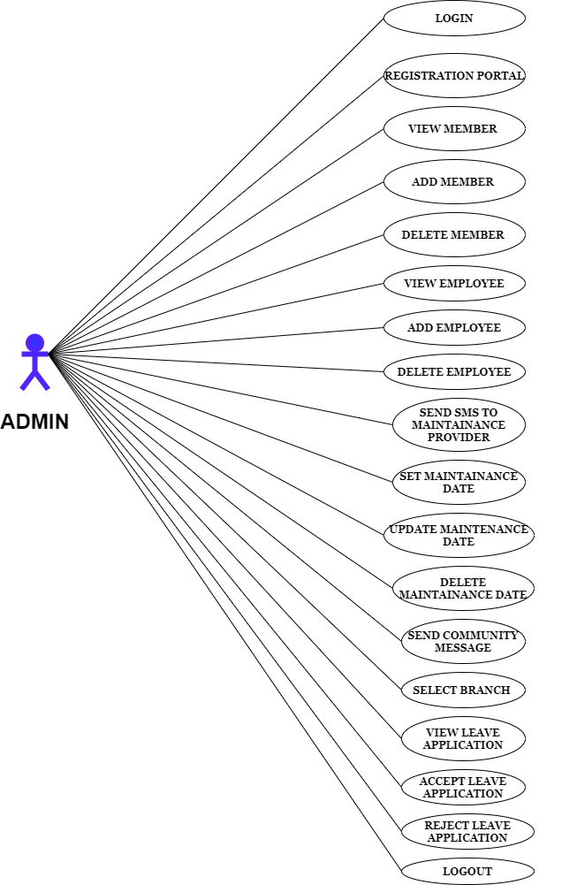

### **B) Employee Diagram:-**

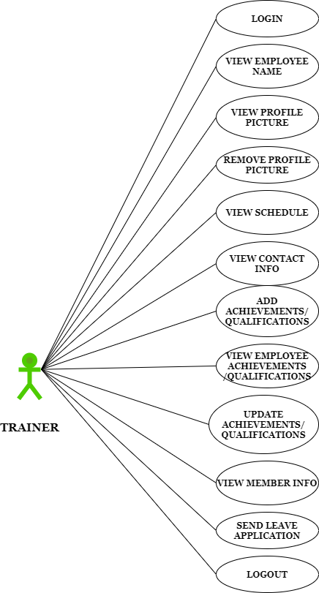

**C) Receptionist Diagram:-**

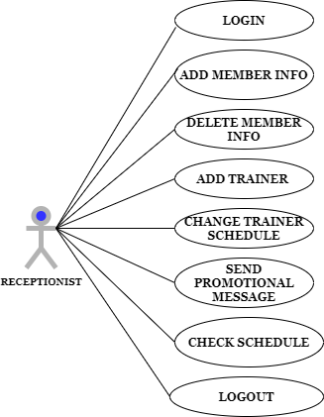

### **D) Member Diagram:-**

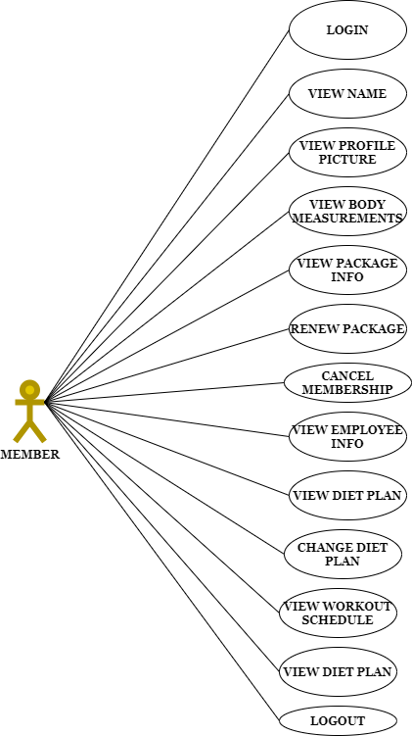

**4.1.2) Sequence Diagram:**

A sequence diagram or system sequence diagram shows object interactions arranged in time sequence in the field of software engineering. It depicts the objects involved in the scenario and the sequence of messages exchanged between the objects needed to carry out the functionality of the scenario.

Sequence diagrams are typically associated with the use case realizations in the logical view of the system under the development. Sequence diagrams for sometimes called event diagrams or event scenarios.

A sequence diagram shows parallel vertical lines, different processes or objects that live simultaneously, and as horizontal arrows, the message exchanged between them, in order in which they occur. This allows the specification of simple runtime scenarios in a graphical manner.

A system sequence diagram should specify and shows following:-

* External Factors
* Messages invoked by actors
* Return values associated with previous messages
* Indication of any loops or iteration area

### **Admin Sequence Diagram:-**

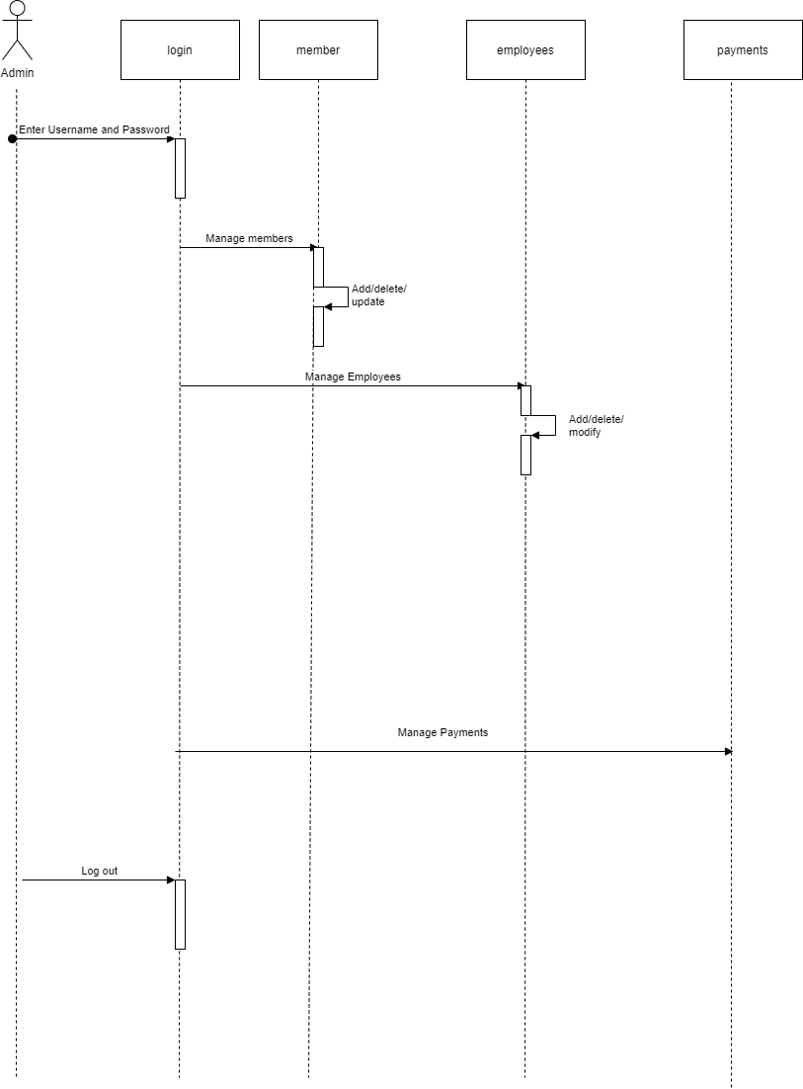

### **B) Member Sequence Diagram:-**

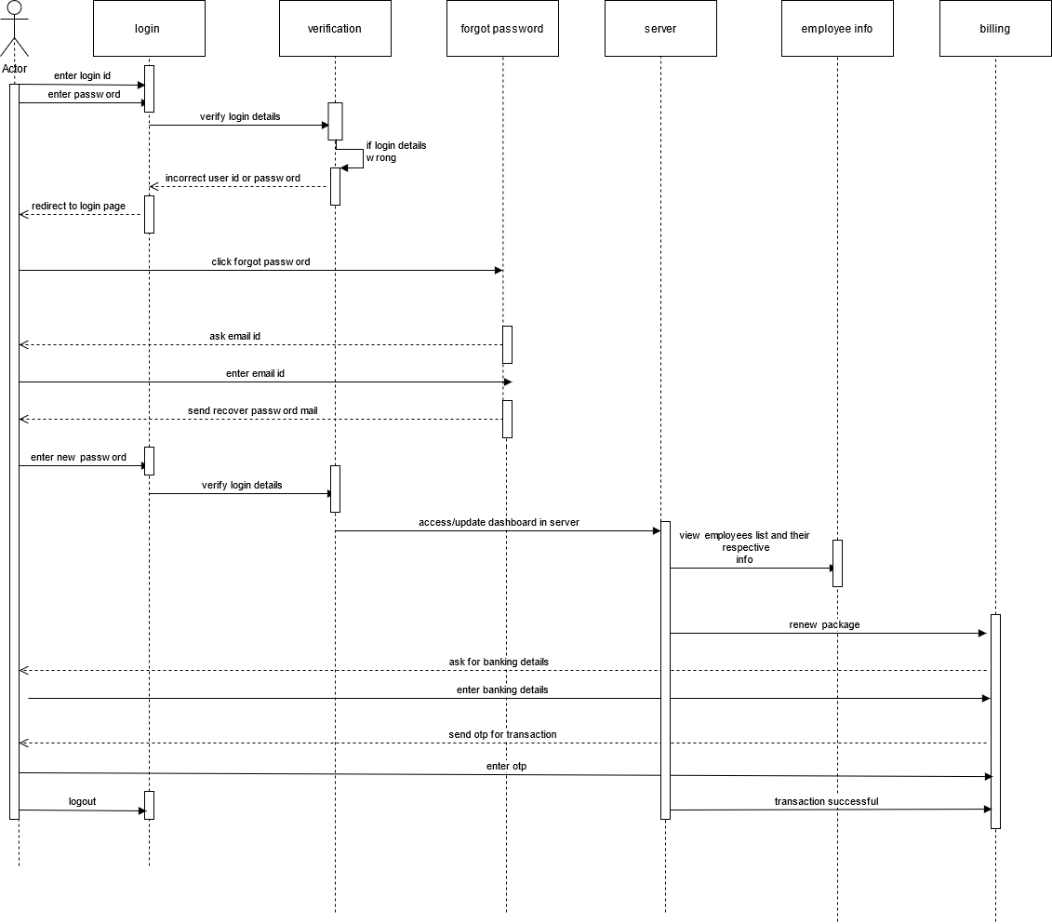

### **C) Employee Sequence Diagram:-**

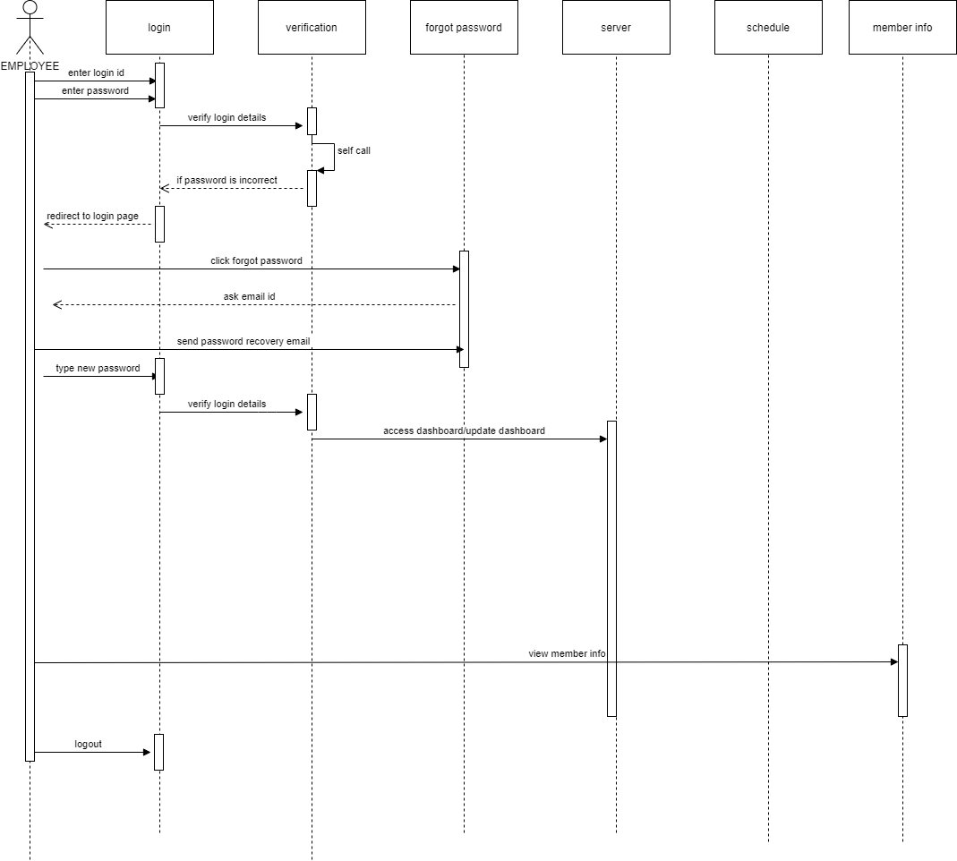

### **4.1.3) Activity Diagram**:-

Activity diagram is another important diagram in UML to describe the dynamic aspects of the system.

Activity Diagram is basically a flowchart to represent the flow from one activity to another activity. The activity can be described as an operation of the system.

The control flow is drawn from one operation to another. This flow can be sequential, branched, or concurrent. Activity diagrams deal with all types of flow control by using different functions such as fork, join, etc.

The basic purpose of activity diagrams is similar to other diagrams. It captures the dynamic behaviour of the system. Other diagrams are used to show the message flow from one object to another object but activity diagram is used to show message flow from one activity to another activity

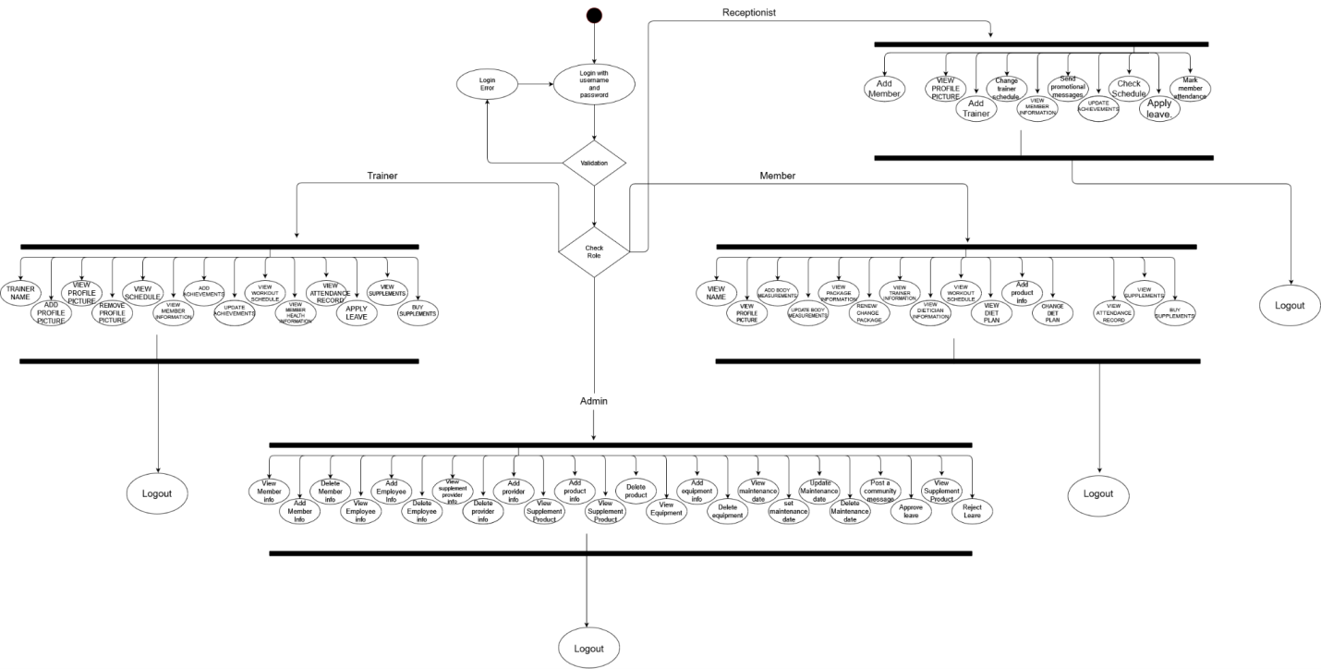

**4.1.4) Decision Tree Diagram**:-

A decision tree is a decision support tool that uses a tree-like model of decisions and their possible consequences, including chance event outcomes, resource costs, and utility. It is one way to display an algorithm that only contains conditional control statements.

Decision trees are commonly used in operations research, specifically in decision analysis, to help identify a strategy most likely to reach a goal, but are also a popular tool in machine learning.

A decision tree is a flowchart-like structure in which each internal node represents a “test” on an attribute, each branch represents the outcome of the test, and each leaf node represents the outcome of the test, and each leaf node represents a class label. The paths from root to leaf represent classification rules. A decision tree consists of three types of nodes:-

1. **Decision Nodes**

These nodes are represented by squares.

1. **Chance Nodes**

These nodes are represented by circles.

1. **End Nodes**

These nodes are represented by triangles

Decision trees are commonly used in operations research and operations management.

Decision trees, influence diagrams, utility functions, and other decision analysis tools and methods are taught to undergraduate students in school of businesses, health economics and public health.

### **Admin Decision Tree:-**

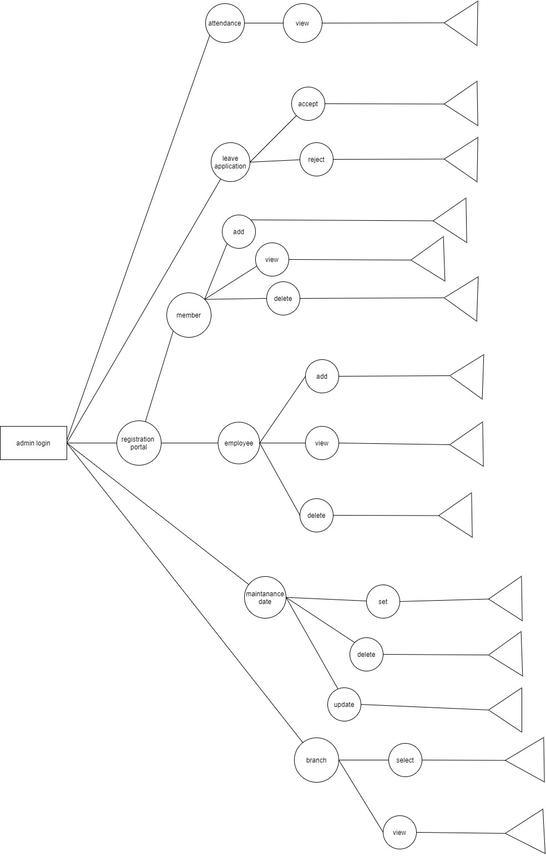

### **B) Employee Decision Tree:-**

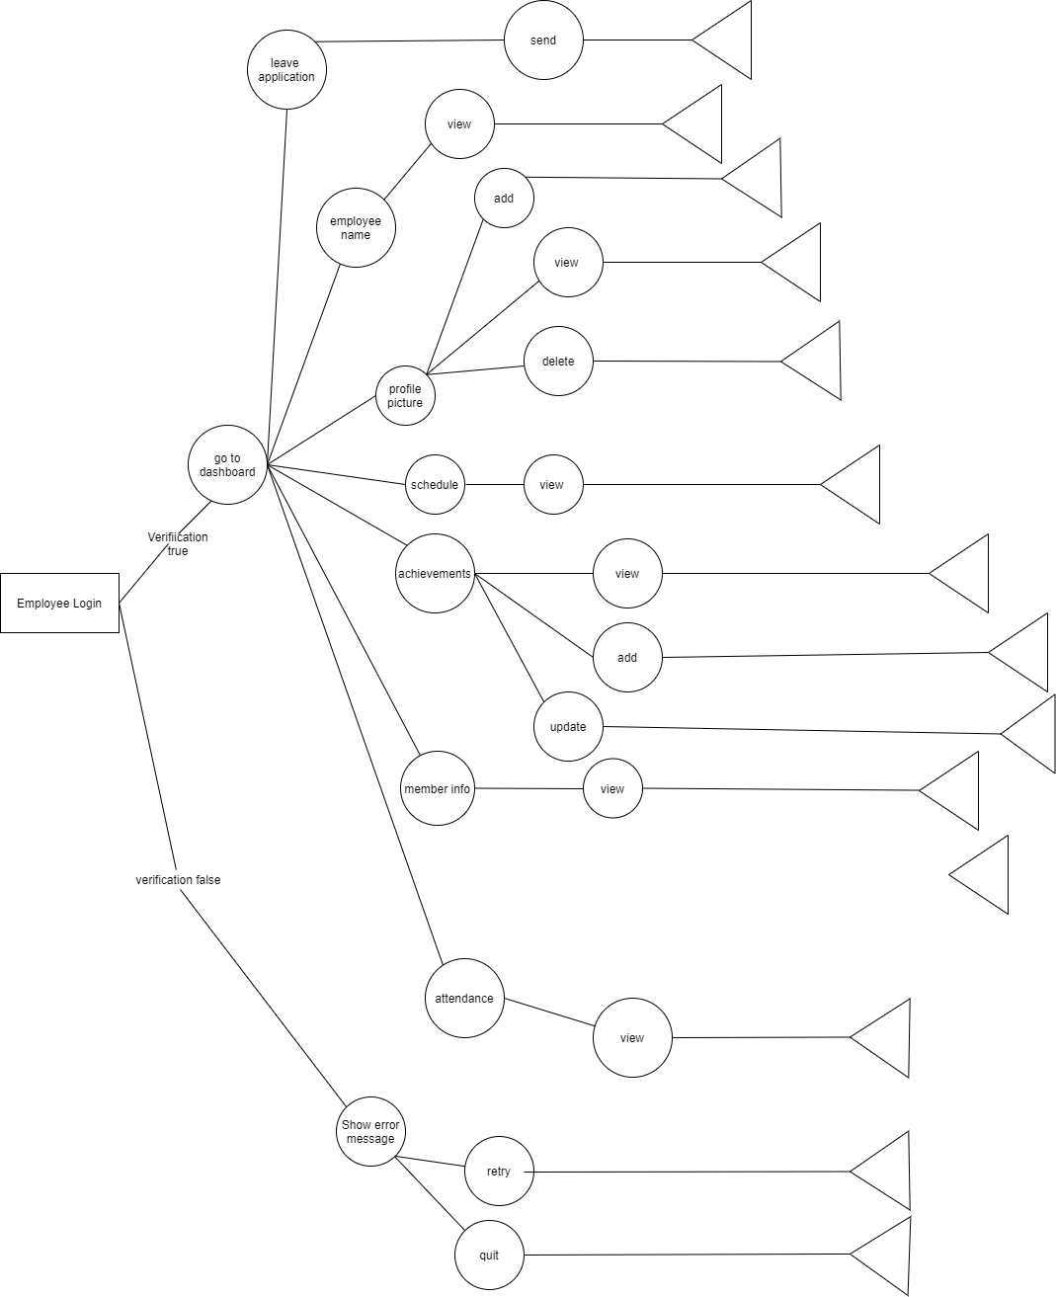

### **Member Decision Tree:-**

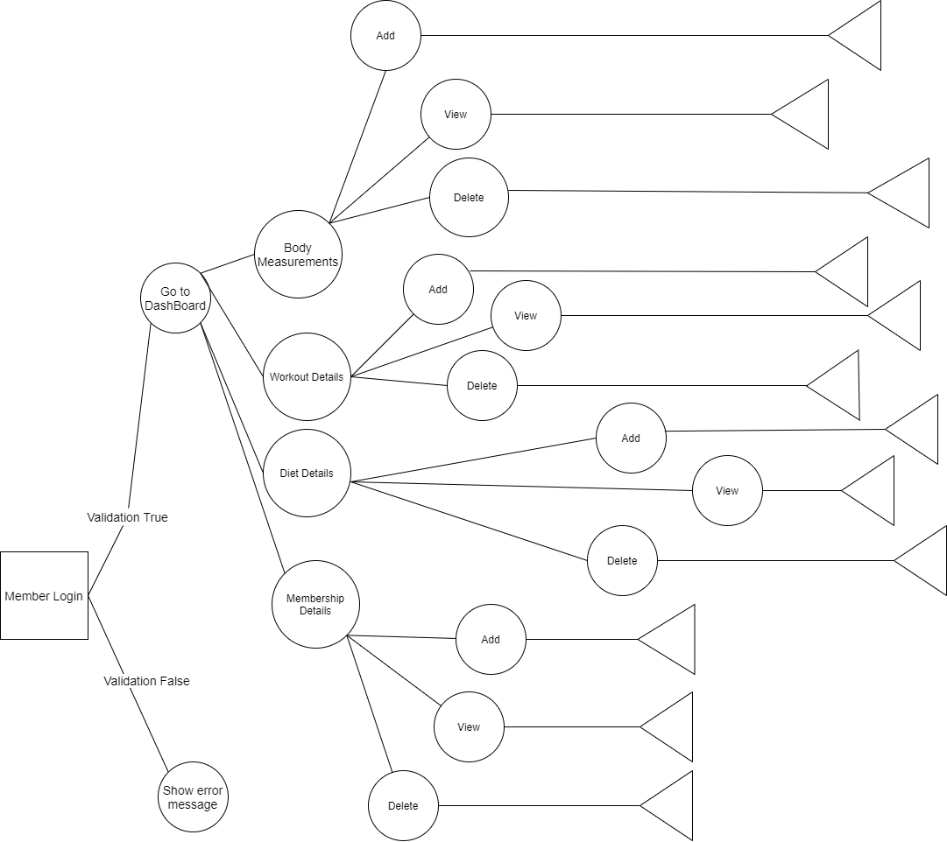

### **4.1.5) ER Diagram:-**

An ER model is a design or blueprint of a database that can later be implemented as a database. The main components of E-R model are: entity set and relationship set.

An ER diagram shows the relationship among entity sets. An entity set is a group of similar entities and these entities can have attributes. In terms of DBMS, an entity is a table or attribute of a table in database, so by showing relationship among tables and their attributes, ER diagram shows the complete logical structure of a database.

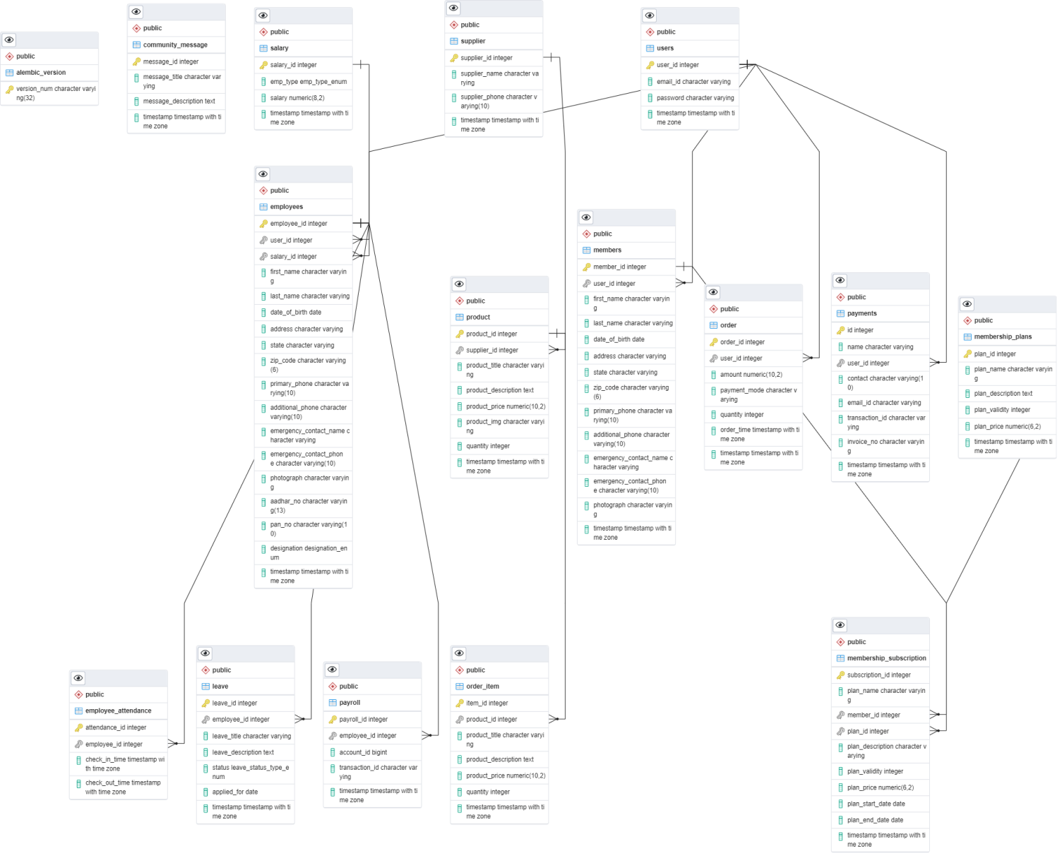

**Chapter 6**

**Testing**

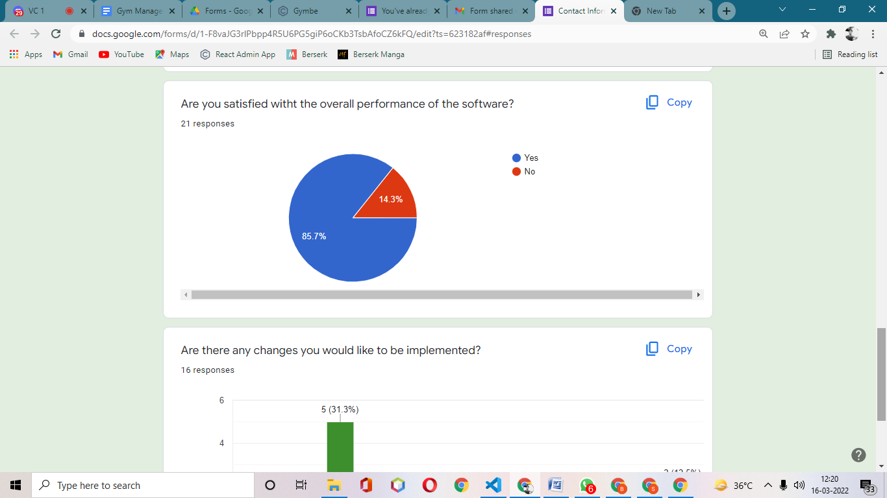

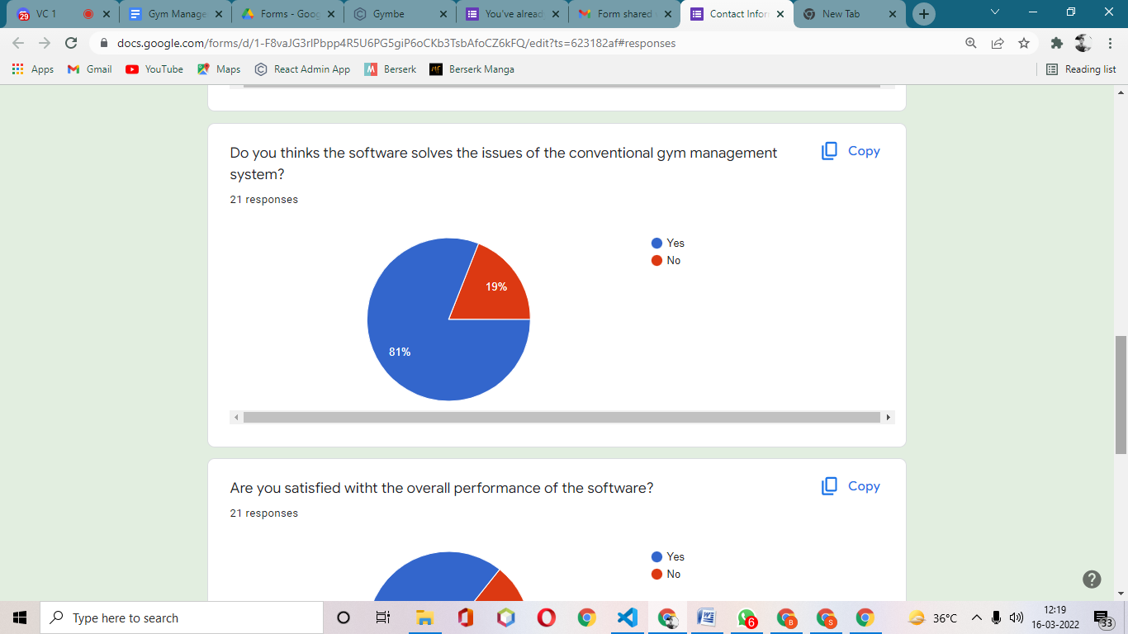

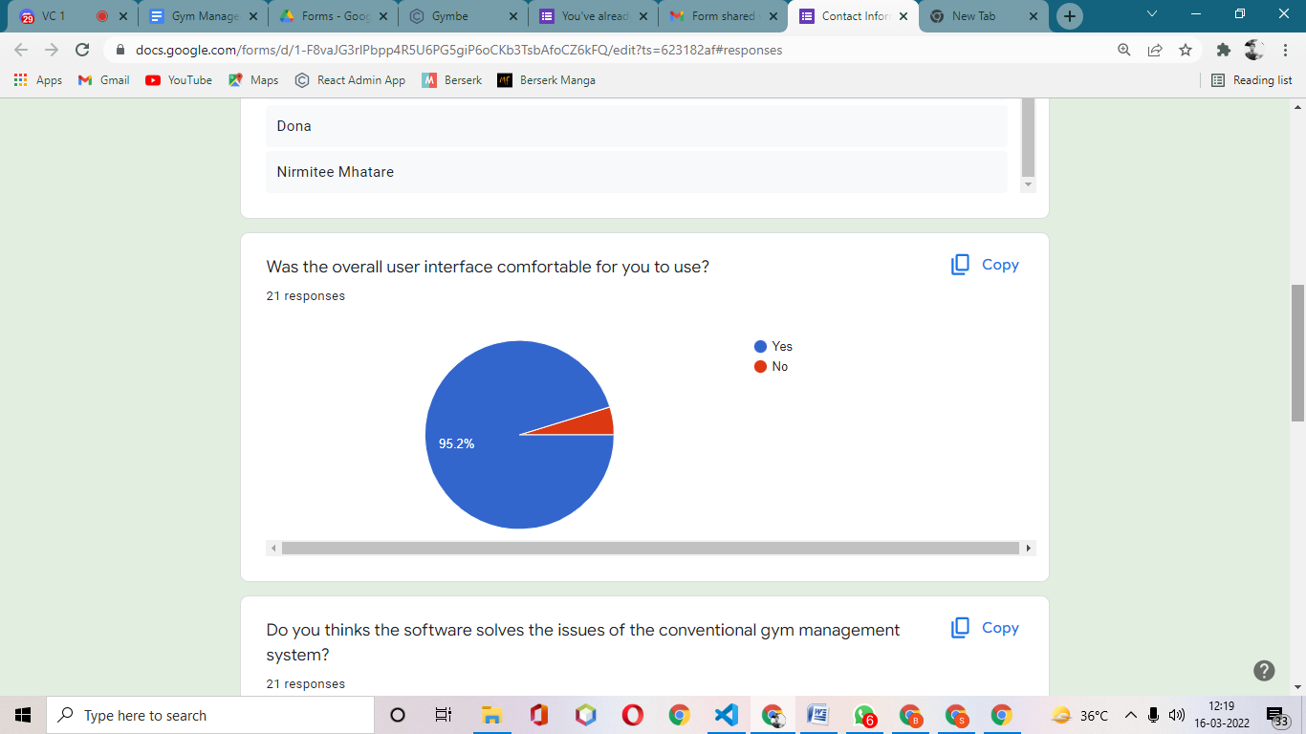

**Chapter 7**

**Code**

**7.1) Screenshot:-**

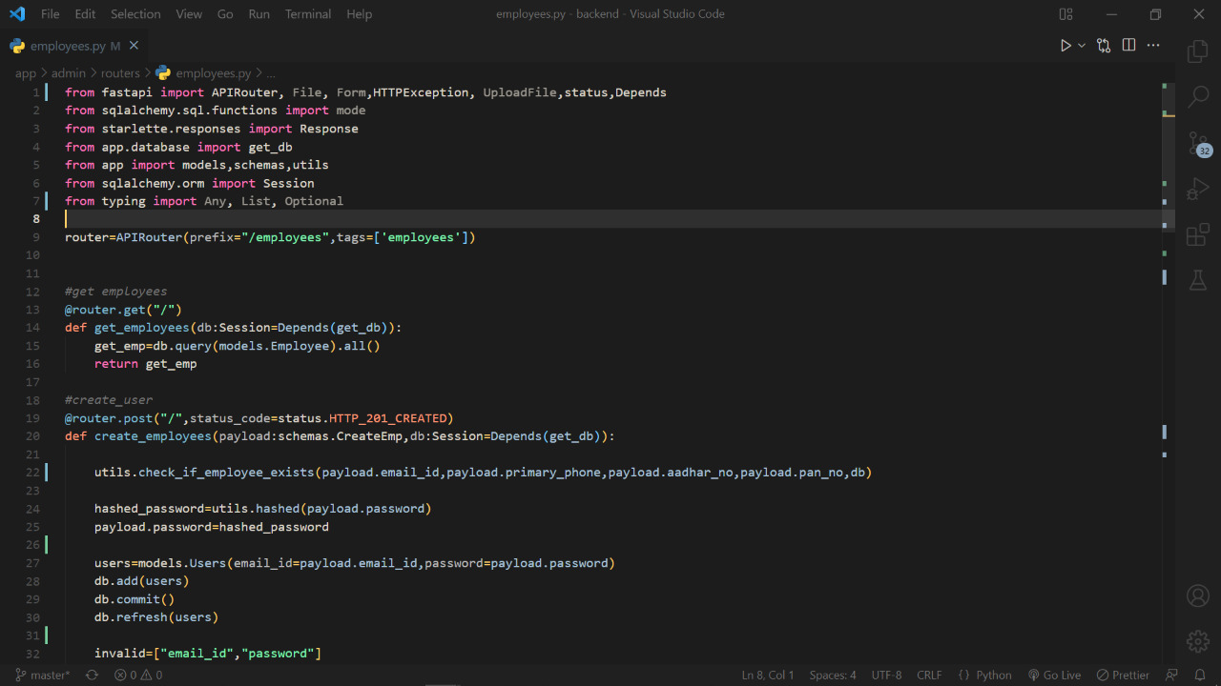

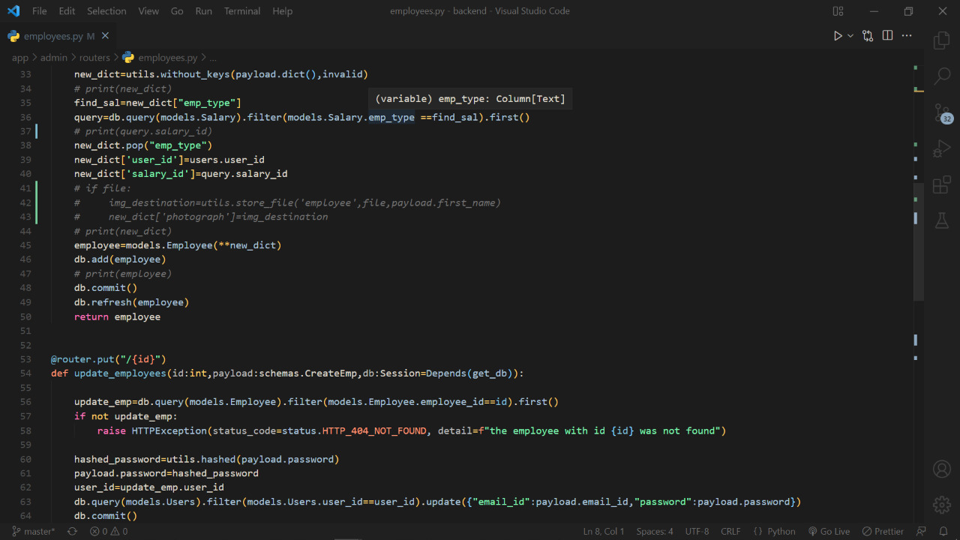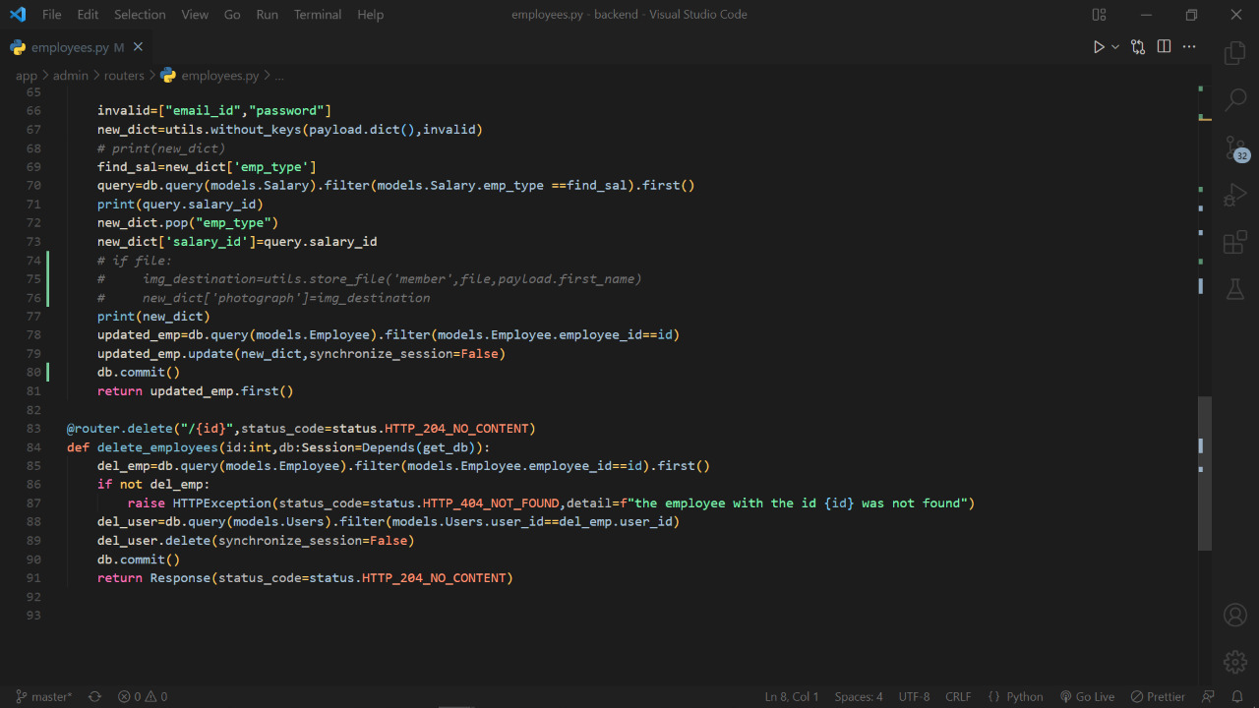

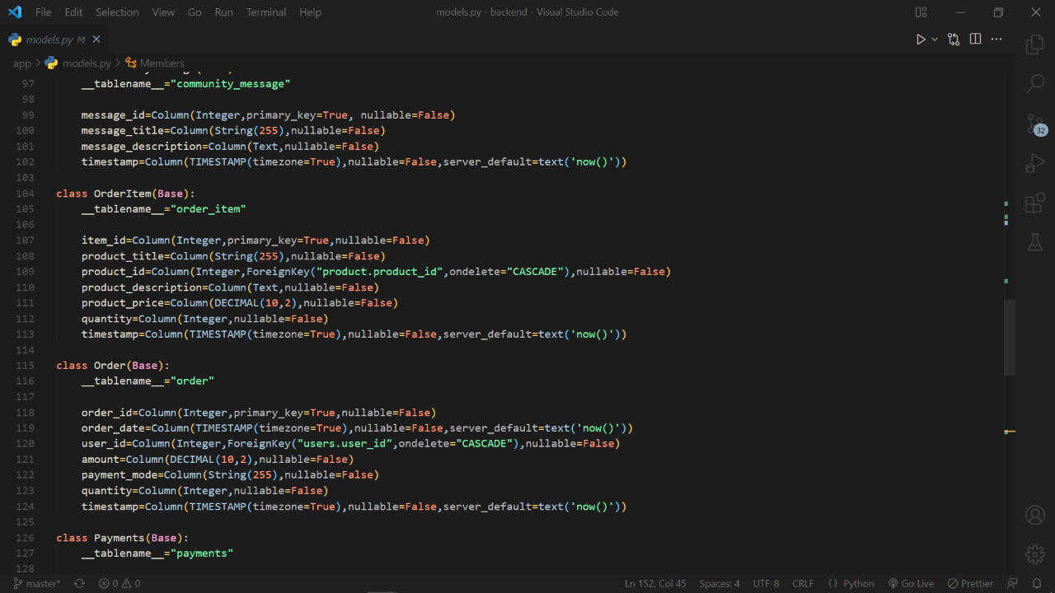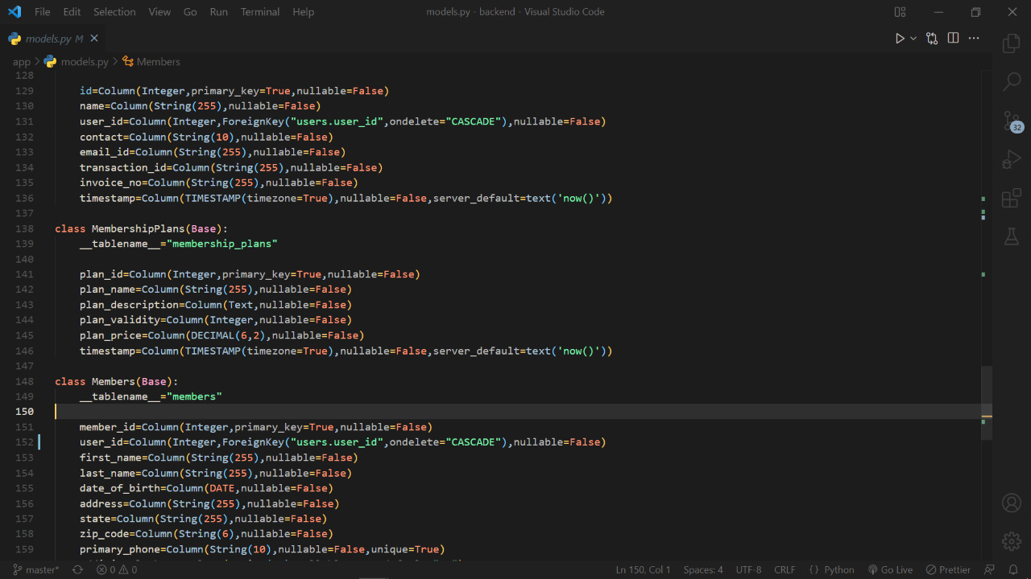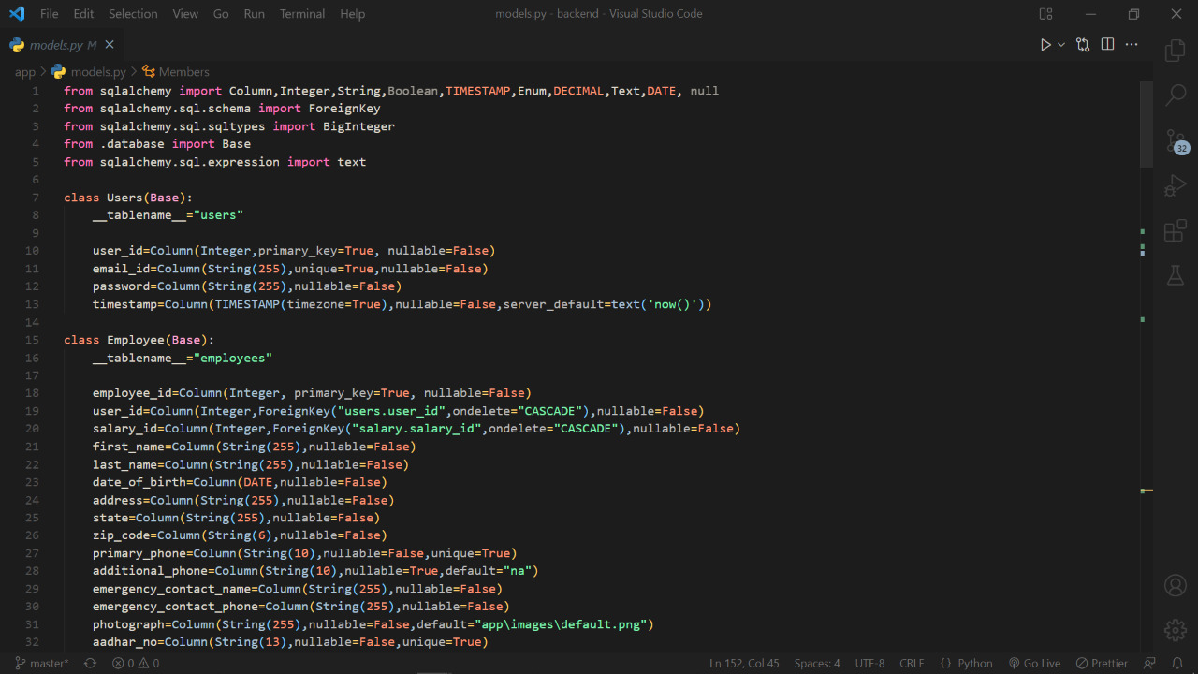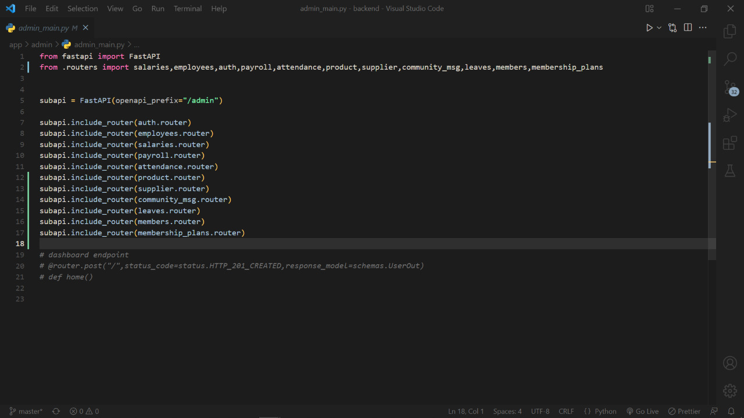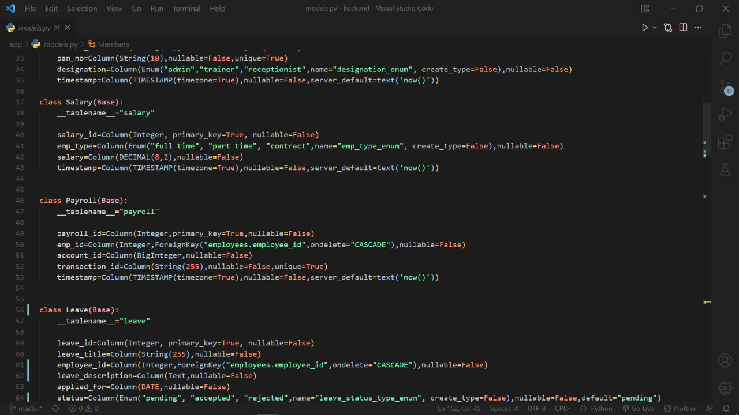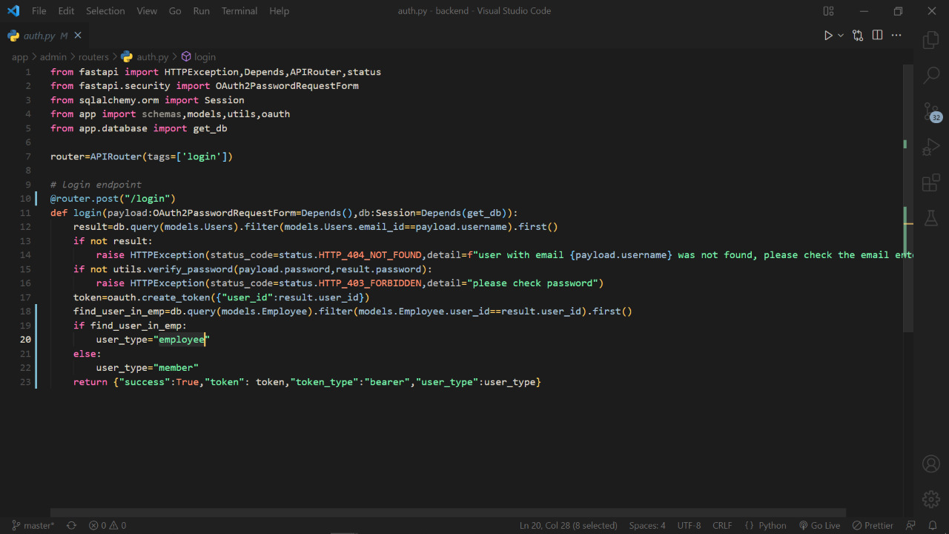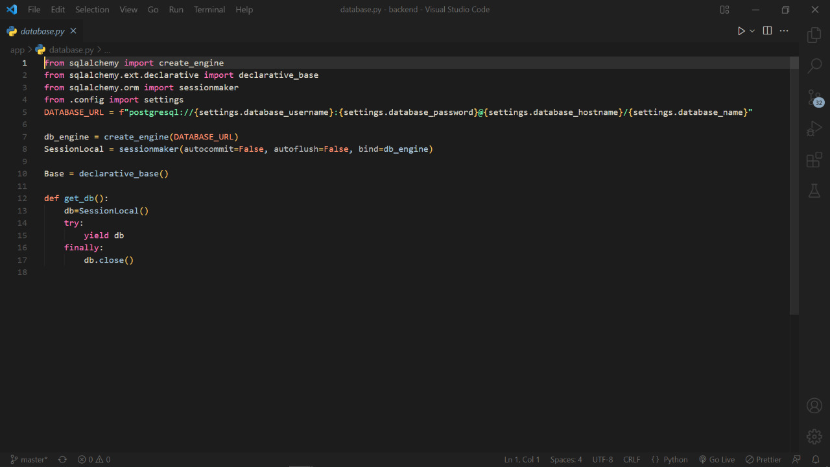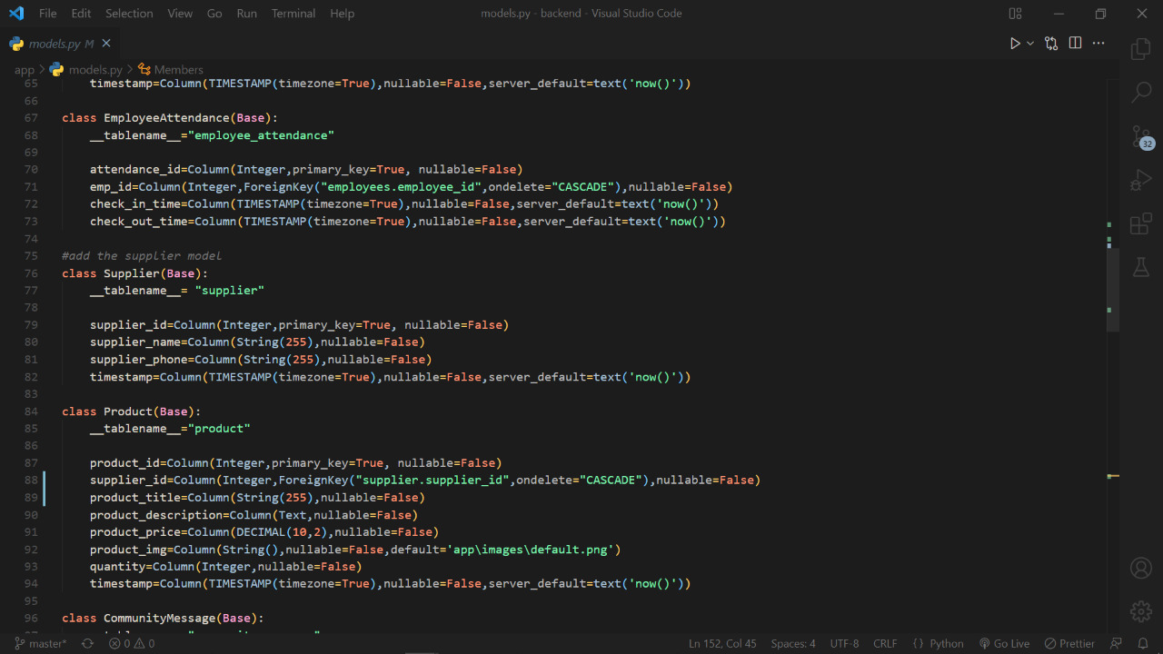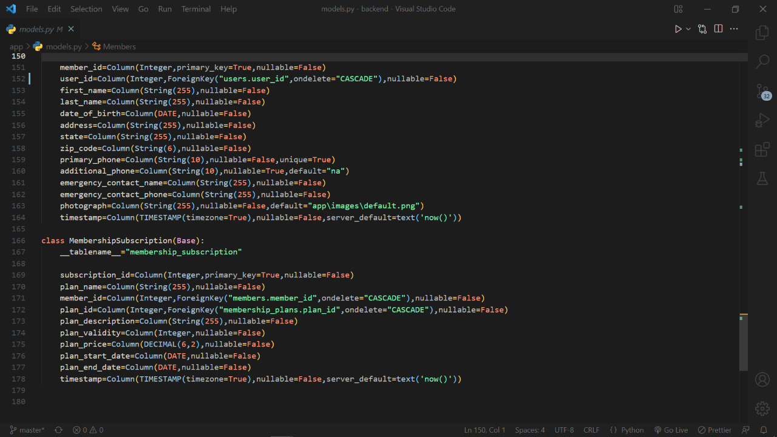

**Chapter 8**

**OUTPUT OF PROJECT**

### **8.1) Login Page:-**

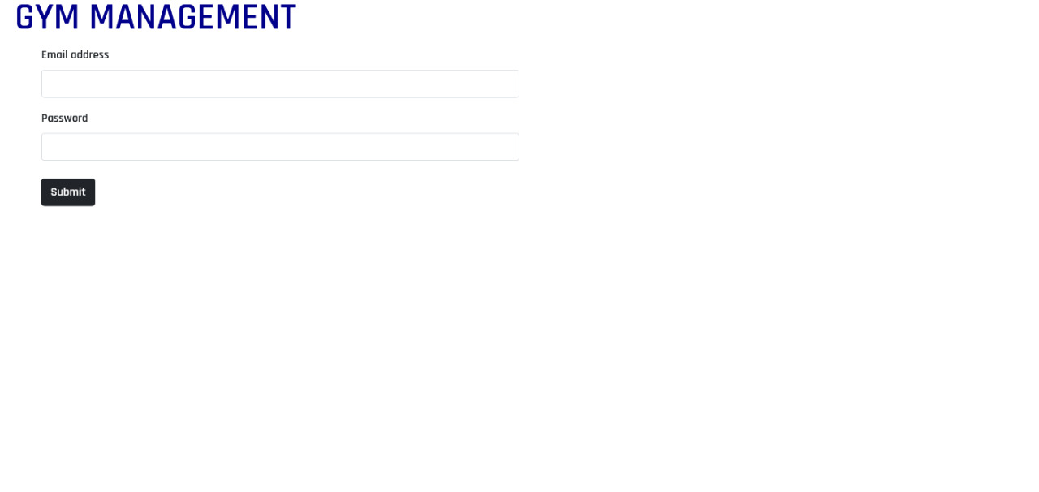

### 

### **8.3) Admin Dashboard:-**

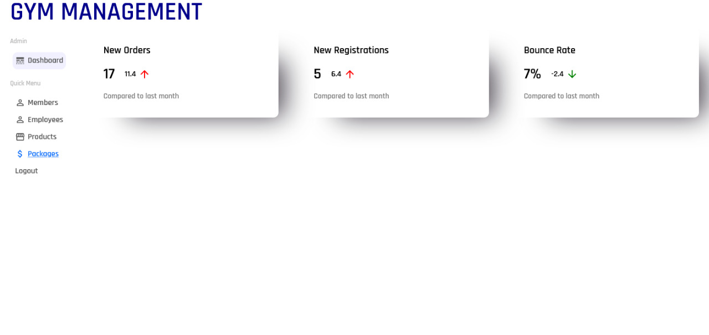

### **8.4) Member Registration Form:-**

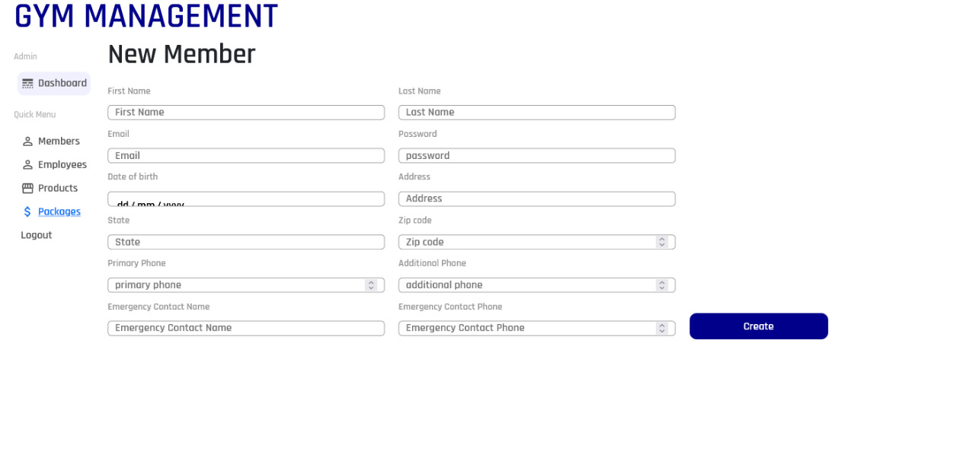

### **8.5) Employee Registration Form:-**

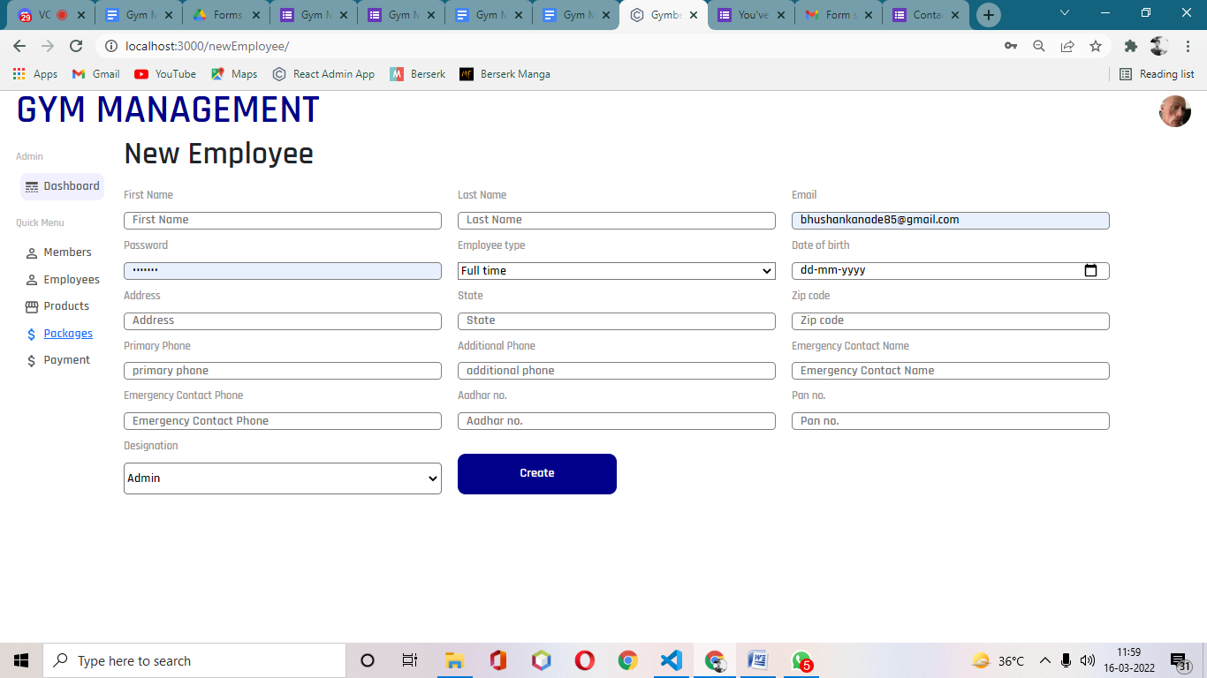

### **8.6) Product Registration Form:-**

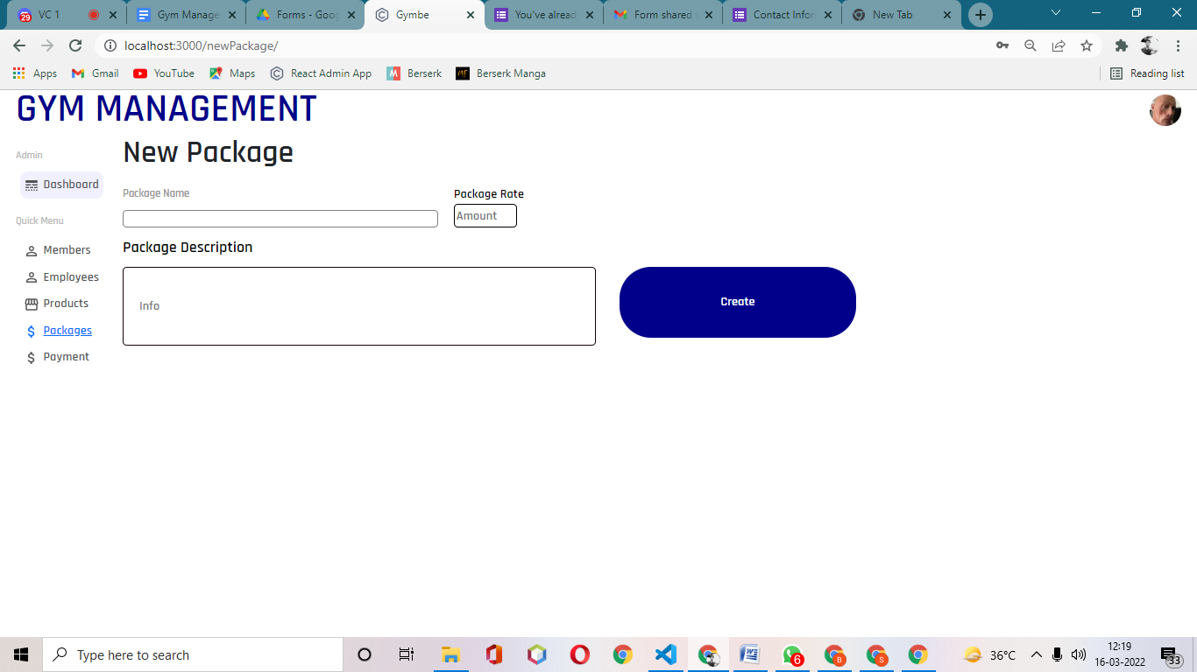

### 

**References**

[**https://fastapi.tiangolo.com/**](https://fastapi.tiangolo.com/)

[**https://www.youtube.com/watch?v=0sOvCWFmrtA&t=51450s**](https://www.youtube.com/watch?v=0sOvCWFmrtA&t=51450s)

[**https://www.youtube.com/watch?v=4UZrsTqkcW4&t=31093s**](https://www.youtube.com/watch?v=4UZrsTqkcW4&t=31093s)

[**https://reactjs.org/**](https://reactjs.org/)

**https://www.youtube.com/watch?v=gY5sGvq-8h8**